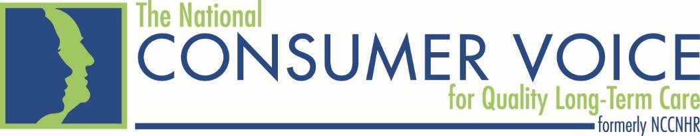

A History of Celebrating
Residents’ Rights

One way to honor residents receiving long-term care is by celebrating Residents' Rights Month. This is an opportunity to show tribute to residents and support long-term care ombudsmen, citizen advocates, facility staff and family members who work to promote and support residents’ rights. Setting aside a month to focus on rights is an effective way to ensure this important topic is recognized in your community, facility or state.

Residents’ Rights Month is celebrated each October and is designated by the National Consumer Voice for Quality Long-Term Care* (the “Consumer Voice”), each year to highlight residents living in all long-term care settings. It is a time to reflect on the importance of the Nursing Home Reform Law of 1987 that promises quality of life, quality of care and rights for each resident. During this month, the Consumer Voice also gives special recognition to the work of thousands of individuals who collaborate daily to help assure dignity, privacy and other basic human rights - often taken for granted in the community - are maintained as an integral part of the lives of residents living in long-term care settings.

Residents’ Rights Month originated as Residents’ Rights Week in 1981 at a Consumer Voice annual meeting. Several nursing home residents in attendance from across the United States decided it would be special for all residents if time were set aside to celebrate residents and their rights, separate from annual National Nursing Home Week events always held in May. The Consumer Voice organized a successful petition drive to persuade Congress to designate a “Residents’ Rights Day.” Senator Claude Pepper (D-FL) and Senator David Pryor (D-AR) responded by introducing a Congressional Resolution for that purpose.

The Consumer Voice was also successful in making arrangements to take five nursing home residents to the White House to meet with President Jimmy Carter’s Special Counselor on Aging, Dr. Harold Sheppard. The residents who attended were Janet Tulloch, Rae Spanover, Joan Knowlton, Ethel Gross and Virginia Caming (all now deceased).

Since 1981, the Consumer Voice has preserved the tradition of celebrating Residents’ Rights, and, in 2011, Residents’ Rights Week was expanded to Residents’ Rights Month. This expansion provides additional time for residents/facility staff, family members, community advocates and ombudsmen to conduct educational programs and festive events to call attention to this important topic.
This year’s theme “Reclaiming My Rights, My Home, My Life” was selected to highlight the need for residents’ rights to be recognized, recovered, and reasserted. The theme emphasizes the recognition of the long-term care facility as the residents’ home, and the importance of residents reclaiming their own lives.

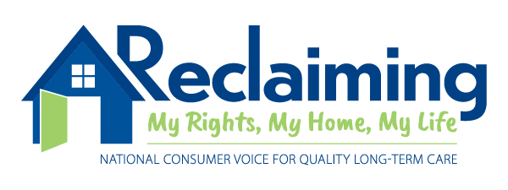

Thank you for working to make Residents’ Rights Month special and meaningful for all involved. Please remember to share information about how you will be celebrating Residents’ Rights Month; the Consumer Voice would like to highlight your celebrations on our website. If you have questions, contact info@theconsumervoice.org.

